EXPERIMENT NO. 2
SETTING UP A ZOHO CREATOR ACCOUNT AND EXPLORING THE PLATFORM ARCHITECTURE AND INTERFACE
NAME:KAYALVIZHI R
ROLL NO:240701251

1. AIM
To set up a Zoho Creator account, create a sample application using a low-code approach, and explore the platform architecture and interface for developing, deploying, and managing applications.

2. INTRODUCTION
Zoho Creator is a low-code application development platform that allows users to create customized applications with minimal programming. It provides a visual development environment for creating forms, reports, pages, dashboards, and workflows.
Low-code development reduces the need for traditional programming and allows applications to be developed using visual components and configuration. It helps users create applications quickly and modify them according to their requirements.
In this experiment, a College Event Management System is developed using Zoho Creator. The application is used to maintain information about college events such as event name, event ID, department, coordinator, date, venue, event type, and status.

3. SETTING UP ZOHO CREATOR
3.1 Creating a Zoho Creator Account
Zoho Creator is accessed through its official website. A new account can be created or an existing account can be used to sign in.
After signing in, the Zoho Creator application development environment is opened. The platform provides a visual interface for designing and managing applications using low-code components.

3.2 Creating the Sample Application
A sample application named College Event Management System is created using Zoho Creator.
The application is designed to manage college event information in an organized manner.
Application Name
College Event Management System
Main Components
- Event Details Form
- Event Status Report
- Event Management Dashboard

4. CREATING THE EVENT DETAILS FORM
A form is used to collect and store information in a Zoho Creator application. Users enter data into the fields provided in the form, and the submitted information is stored automatically.
For this application, a form named Event Details is created.
Fields Used in the Event Details Form
S.No. | Field Name | Field Type
1 | Event Name | Single Line
2 | Event ID | Single Line
3 | Department | Dropdown
4 | Event Coordinator | Single Line
5 | Event Date | Date
6 | Venue | Single Line
7 | Event Type | Dropdown
8 | Status | Dropdown
Dropdown Values
Department:
- CSE
- ECE
- IT
- EEE
- Mechanical
Event Type:
- Technical
- Cultural
- Sports
- Workshop
- Seminar
Status:
- Upcoming
- Ongoing
- Completed
The form is used to enter and store the details of college events.
Figure 1: Event Details Form
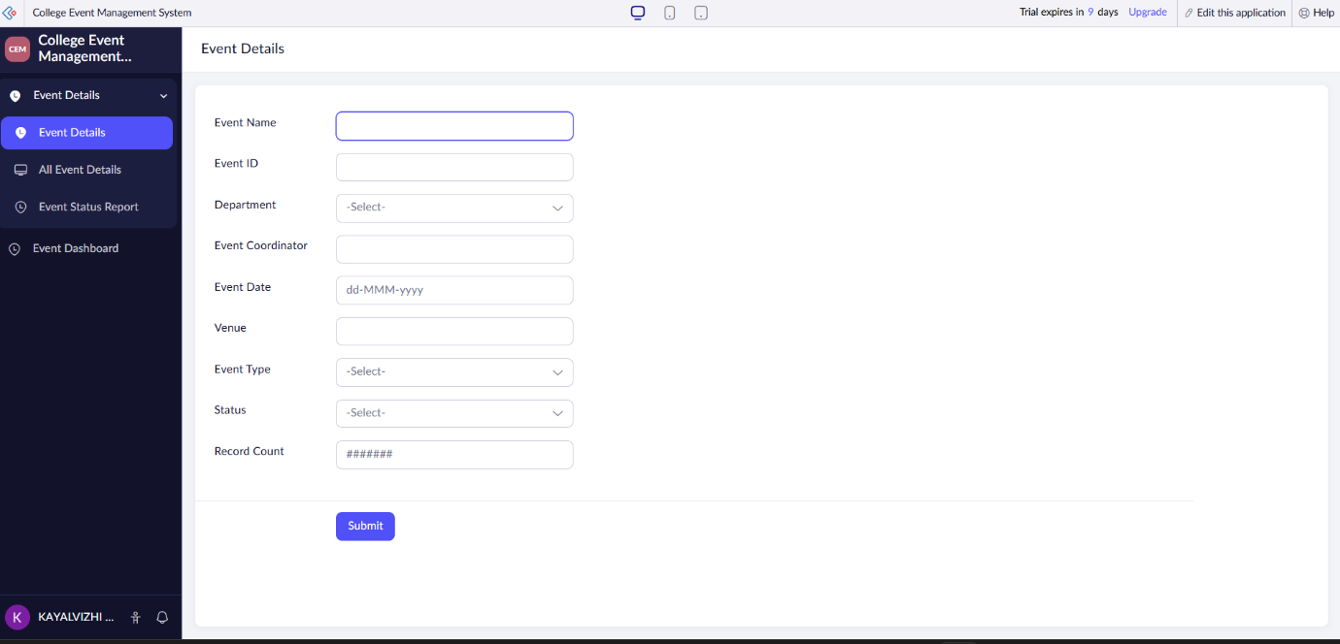
Explanation
The Event Details Form is used to collect information about college events. It contains fields for event name, event ID, department, coordinator, event date, venue, event type, and status. The information entered through the form is stored automatically in the application.

5. ENTERING SAMPLE EVENT DATA
After creating the Event Details Form, sample event records are entered into the application.
The following five records are used:
Event Name | Event ID | Department | Event Coordinator | Event Date | Venue | Event Type | Status
Tech Fest 2026 | EVT001 | CSE | Rithika | 15-08-2026 | Seminar Hall | Technical | Upcoming
Code Challenge | EVT002 | IT | Priya | 20-08-2026 | Lab 1 | Workshop | Upcoming
Cultural Fest | EVT003 | ECE | Arun | 25-07-2026 | Auditorium | Cultural | Completed
AI Seminar | EVT004 | CSE | Divya | 10-08-2026 | Conference Hall | Seminar | Ongoing
Sports Meet | EVT005 | EEE | Kavin | 05-07-2026 | College Ground | Sports | Completed
These sample records are used to demonstrate the report and dashboard features.

6. CREATING THE EVENT STATUS REPORT
A report is used to display and manage the information stored through a form. It presents the collected data in an organized format and helps users view and manage records.
For this application, a report named Event Status Report is created using the Event Details form.
A Kanban-style report can be used to organize events according to their status.
The events are grouped into:
- Upcoming
- Ongoing
- Completed
Figure 2: Event Status Report
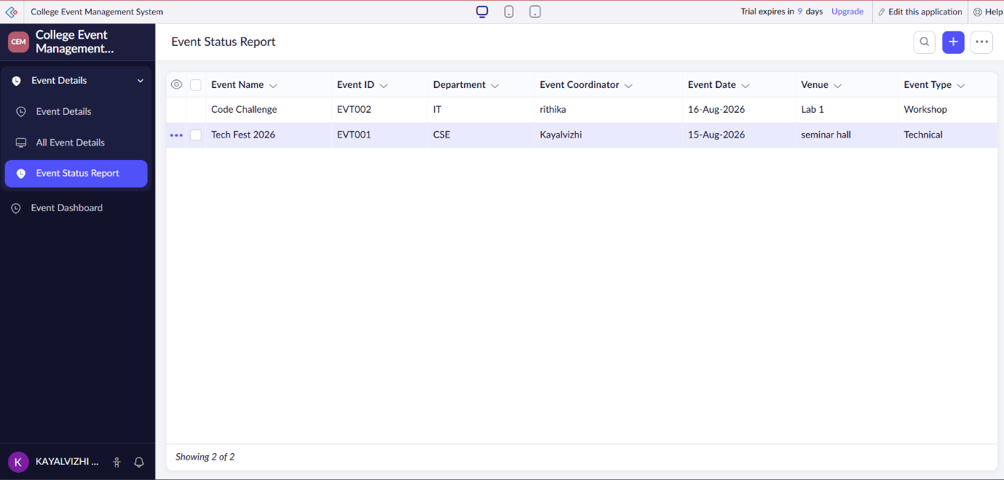
Explanation
The Event Status Report displays the event records entered through the Event Details Form. The report organizes events according to their current status. This makes it easier to identify upcoming, ongoing, and completed events.

7. CREATING THE EVENT MANAGEMENT DASHBOARD
A dashboard provides a visual representation of important application information. In Zoho Creator, a dashboard can be created using a Page and different components such as charts, panels, and reports.
For this application, a page named Event Dashboard is created.
The dashboard contains:
- Event Overview and Status Tracking
- Event Status Overview Chart
- Event Status Report
A chart is used to display the distribution of events according to their status.
Event Status Distribution
- Upcoming – 2 events
- Ongoing – 1 event
- Completed – 2 events
Figure 3: Event Management Dashboard
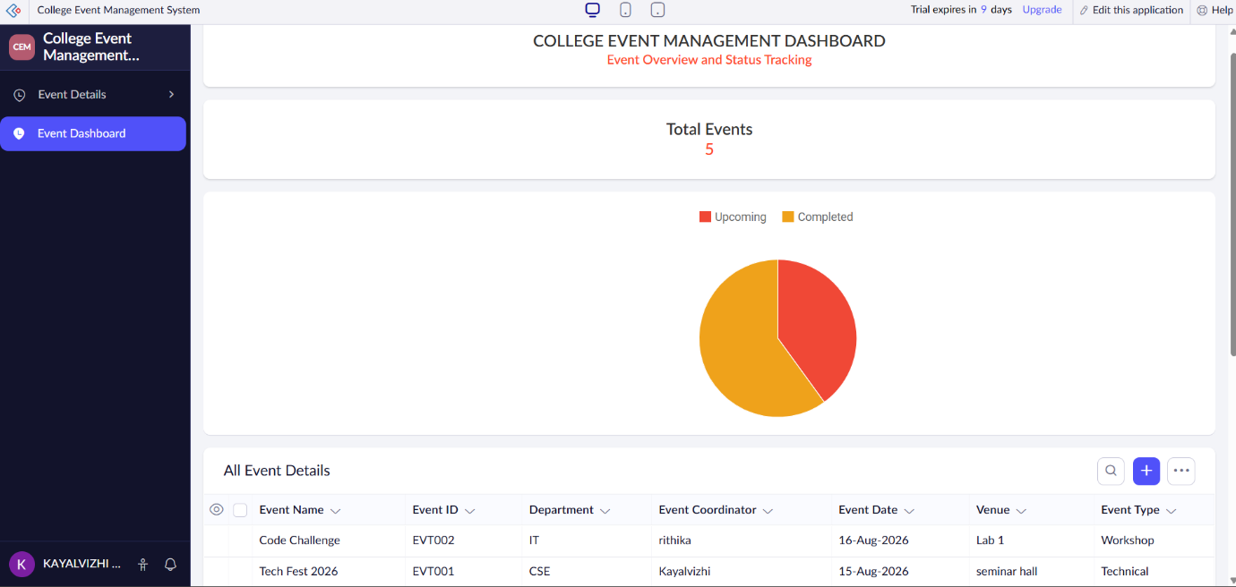
Explanation
The Event Management Dashboard provides a visual summary of college events. It displays the event status using a chart and provides quick access to event information through the report. The dashboard makes the application more user-friendly and helps users understand event information quickly.

8. EXPLORING THE PLATFORM ARCHITECTURE AND INTERFACE
8.1 DEVELOP
Zoho Creator provides a visual low-code environment for developing applications with minimal programming.
Users can create forms, reports, pages, dashboards, and workflows using visual components.
The platform helps developers create and customize applications quickly according to their requirements.

8.2 DEPLOY
Zoho Creator allows completed applications to be published and accessed by authorized users.
Applications can be accessed through supported web and mobile interfaces after deployment.
User permissions and access controls can be configured according to the requirements of the application.

8.3 MANAGE
Zoho Creator provides features for managing application data, users, permissions, workflows, and settings.
Administrators can monitor and maintain the application after deployment.
The application can be modified and updated whenever new requirements arise.

9. ZOHO CREATOR INTERFACE
9.1 Application Builder
The Application Builder provides a visual environment for designing and customizing applications. It allows users to add and configure different application components.
9.2 Forms
Forms are used to collect and store information from users. They provide input fields through which users can submit data.
9.3 Reports
Reports are used to display, organize, filter, and manage the data stored in the application.
9.4 Pages
Pages are used to create customized interfaces and dashboards for presenting application information.
9.5 Workflows
Workflows are used to automate tasks and actions based on predefined conditions and events.
9.6 Settings
Settings are used to configure application properties, users, permissions, and other application-related options.

10. ADVANTAGES OF ZOHO CREATOR
- Reduces the amount of traditional programming required.
- Provides a user-friendly visual development environment.
- Helps in developing applications quickly.
- Supports forms, reports, pages, dashboards, and workflows.
- Provides centralized data management.
- Simplifies application maintenance and modification.
- Supports automation of application processes.
- Provides controlled access and user permissions.

11. RESULT
Thus, a Zoho Creator account was successfully set up and a College Event Management System was developed using the low-code development approach. The Event Details Form, Event Status Report, and Event Management Dashboard were successfully created. The platform architecture and interface were explored, including the Develop, Deploy, and Manage features of Zoho Creator.

